Chapter – 9: Friction

# Friction

* Take a ball – role it on floor – stops after some time
* Stop peddling – cycle stops
* Force – stop moving objects
* Some force – acts on objects – change state of motion – moving to rest
* This force – **frictional force** or **friction**
* Contact force
* Ball moves on floor – both surfaces in contact – rub against each other – friction generated
* Friction – opposite direction of motion
* Friction opposes motion
* Objects – overcome friction – keep moving
* Friction – also exists – only contact – no motion
* Brick on floor – make it move – apply force (Muscular) – overcome friction between brick and floor
* More bricks – more friction – more pressure on surfaces

**What causes friction?**

* 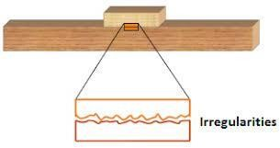Irregularities of 2 surfaces in contact – lock into each other – create friction
* Characteristics –
  + Acts only when contact is there
  + Always opposes the motion
  + Increases when surfaces are pressed harder
  + Causes wear and tear (damage) of surfaces in contact

# Types of friction

* Static friction
  + Between 2 surfaces in contact – no relative movement
  + Static friction – force applied at instant (exact time) – object starts to move
  + Heavy box on floor – push it – force applied by you to make it move – static friction
* Sliding friction
  + Between 2 surfaces in contact – in motion
  + Sliding friction – force required to keep the object moving
  + Already moving box – apply force to keep it moving – sliding friction
  + Always less than – static friction – easier to keep it moving than moving a stationary object
* Rolling friction
  + Between 2 surfaces in contact – 1 of them rolling over other
  + Lesser magnitude than sliding friction
  + Wheels in suitcase – offer less friction – make it easy to carry luggage
  + Type of friction – can be changed
  + Ball bearings – convert sliding friction to rolling friction – ensure smooth motion and prevent wear and tear
* Fluid friction
  + Opposes movement within fluids (liquids and gases)
  + Also known as drag
  + Air exerts force on moving objects
  + Cycle stops moving – not only by rolling friction – but also by fluid friction by air
  + Experienced by aeroplane
  + Boat stops when boatmen stops rowing – fluid friction by water
  + Depends on nature of fluid
  + Easier to stir water – harder to stir honey
  + Honey – more thicker or viscous – more friction
  + Depends on speed with respect to fluid
  + Higher speed – higher friction
  + Depends on shape of object
  + Objects shaped – streamlined – require less force to overcome friction

# Factors affecting friction

* Magnitude of friction depends on –
  + Nature of surfaces in contact
  + Weight of body
  + Pushing a box on cemented floor – easy – it is smoother – pushing a box on grass – difficult – it is rough
  + Pushing a lighter box – easy – less weight – pushing a heavier box – harder – more weight
  + Force – body presses down the other
  + Take a brick – tie some weight on one end – hang the weight – with a pulley over the edge of table – leave it gently – brick moves some distance
  + Now add some more weight to the hanging weight – bricks move greater distance

# Methods of reducing friction

* Friction – opposes motion
* Sometimes – cause wear and tear (damage)
* Methods to reduce friction –
  + Oiling –
    - Make the surfaces smoother – done by oiling (applying oil to surface) – **lubrication**
    - Movement improved – less fraction
  + Polishing –
    - Make the surfaces smoother – done by polishing surfaces in contact
  + Streamlining –
    - Object – flowing in water – receive friction from water
    - Object – floating in air – recieve friction from air
    - Reduce by **streamlining** – narrow in front and back, broad in centre – ships and aeroplane
    - All birds – streamline by nature
    - All fish – streamline by nature
  + Using anti-friction alloys –
    - Steel slides on steel – more friction – steel slides on bronze – less friction
    - Reduce friction by using alloys
  + Using air cushions –
    - Reduce friction by – thin cushion of compressed air – between solid surfaces in motion
    - Hovercraft – work on this concept

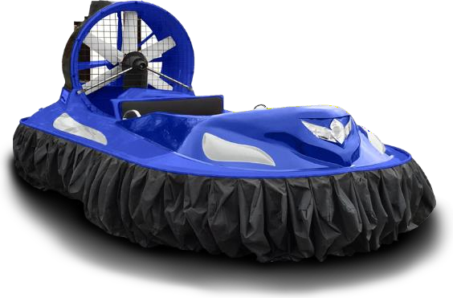

* + Using ball bearings –
    - Try to walk over marbles – you will slip
    - Circular marbles – reduce friction
    - Same concept – used in machines
    - Ball bearings – reduce friction – between moving surfaces
    - Made of ceramic or hard steel
    - Reduce friction by converting sliding friction to rolling friction

# Methods of increasing friction

* Sometimes – necessary to oppose motion
* Methods to increase friction –
  + Treading of tyres –
    - Tyres – grooves (design) on the surface – increase friction
    - Tyres do not skid
    - 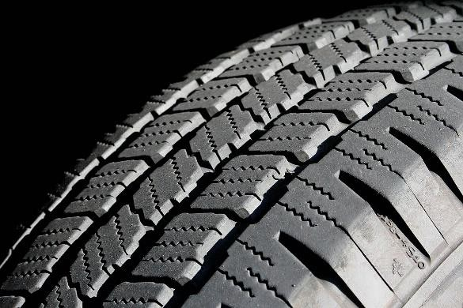Synthetic rubber – offer lots of friction
  + Sanding –
    - Sand – thrown on tracks with snow – increases friction – vehicles do not skid
  + Athletes and players – **spikes** on boots – run very fast – do not slip
  + Cleaning floors – **hard brushes** – increase efficiency
  + Sides of matchboxes – made **rough** – match rubbed – enough friction to light matchstick

# Advantages and disadvantages of friction

* Advantages –
  + Helps in walking – friction between foot (sole) and ground – wet floor – you may slip
  + Helps in writing – friction between pen and paper – oily surface of paper – pen may slip
  + Friction produces heat – friction between matchstick and matchbox – matchstick catches fire
  + Wood – friction between wood and axe – wood cut easily
  + Helps in all the daily jobs – opening lid (cap)
* Disadvantages –
  + Parts of machine – wear and tear – continuous friction
  + Sole of shoes after some time – wear off – regular use
  + Friction produce heat – car parts, engines – heat up
  + Moving objects – overcome friction – waste energy